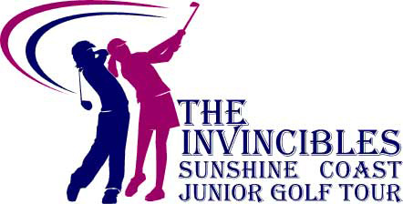

The Invincibles Tour 2021
February 28 : Caloundra Junior Classic.
March 7 : Invincibles Match Play Championship, Twin Waters Golf Club.
March 21 : Invincibles Match Play Championship, Pelican Waters Golf Club
March 28 : Tin Can Bay Junior Classic.
April 12 / 13 : Pelican Waters 2Day Easter Classic.
April 25 : Nambour Junior Classic.
May 9 : Redcliffe Junior Classic.
June 29 – July 2 : QLD Boys & Girls Amateur Championship, Bargara Golf Club.
July 11 : Noosa Springs Junior Classic.
July 25 : Mount Coolum Junior Open.
August 13 : Invincibles IGA Corporate Golf Day, Twin Waters Golf Club.
August 29 : Maroochy River Junior Open.
September 12 : Peregian Junior Classic.
September 19/20/21 : Katherine Kirk Classic, Maroochy River.
September 21/22/23/24 : Gary Player Classic, Pacific Golf Club.
September 26/27/28/29 : Invincibles IGA Junior Masters, Peregian Springs, Twin Waters, Pelican Waters, Noosa Springs.
October : Pelican Waters Special Junior Open (TBC).
October 17 : Headland Junior Classic.
October 24 : IBF Junior Classic, Twin Waters Golf Club.
November 7 : Noosa Junior Classic, Noosa Golf Club.
November 28 : Invincibles Gold Cup & Presentation Dinner, Twin Waters Golf Club.

